CS 255 System Design Document

UML Diagrams

UML Use Case Diagram
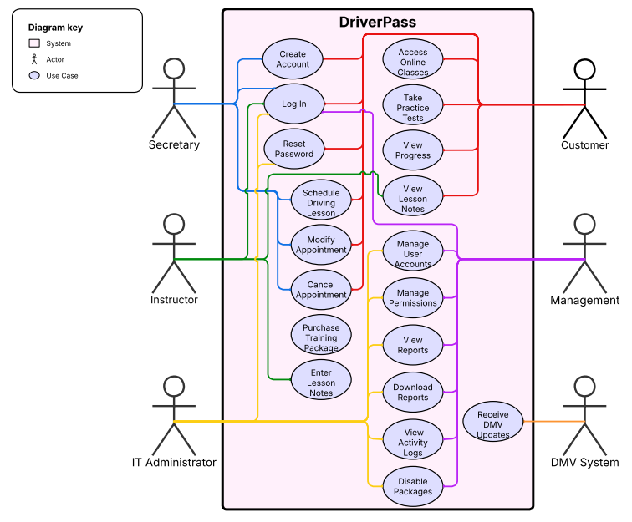

UML Activity Diagrams
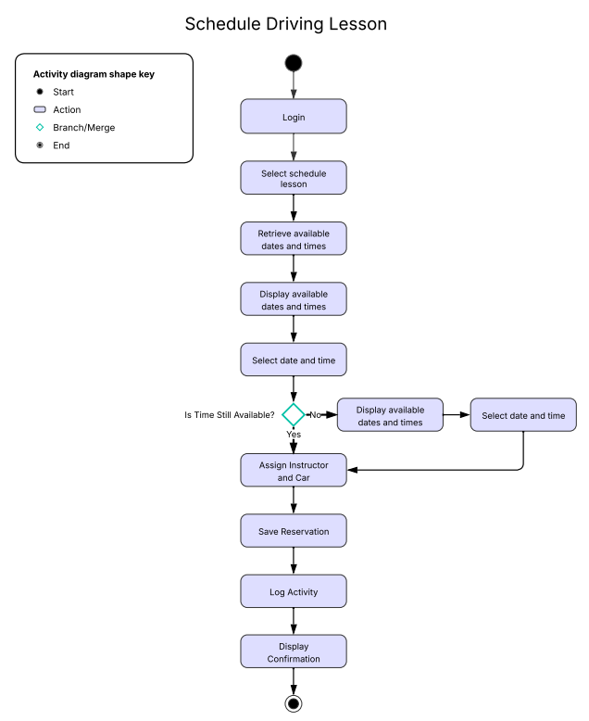
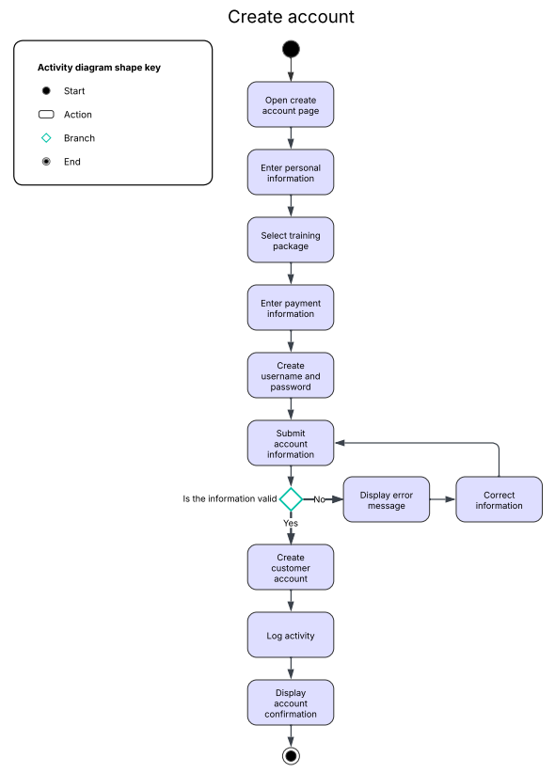

UML Sequence Diagram

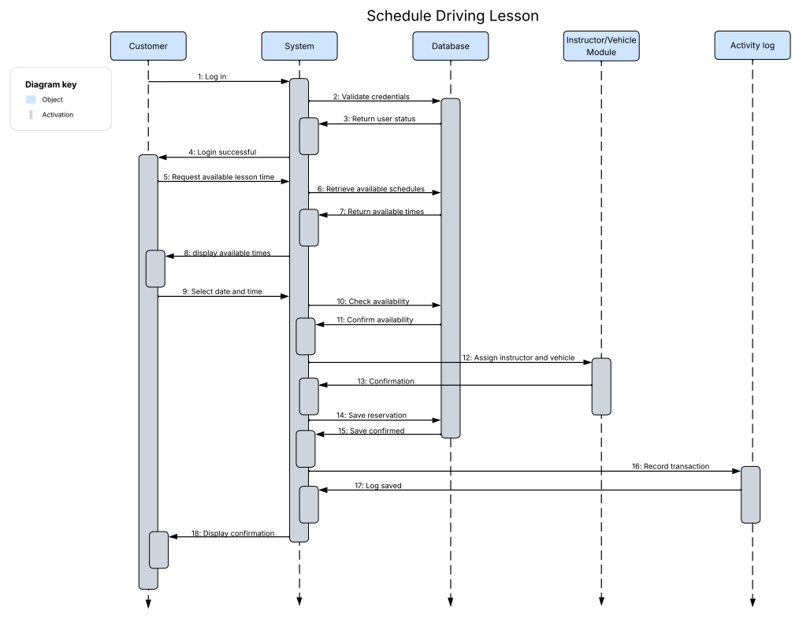

UML Class Diagram
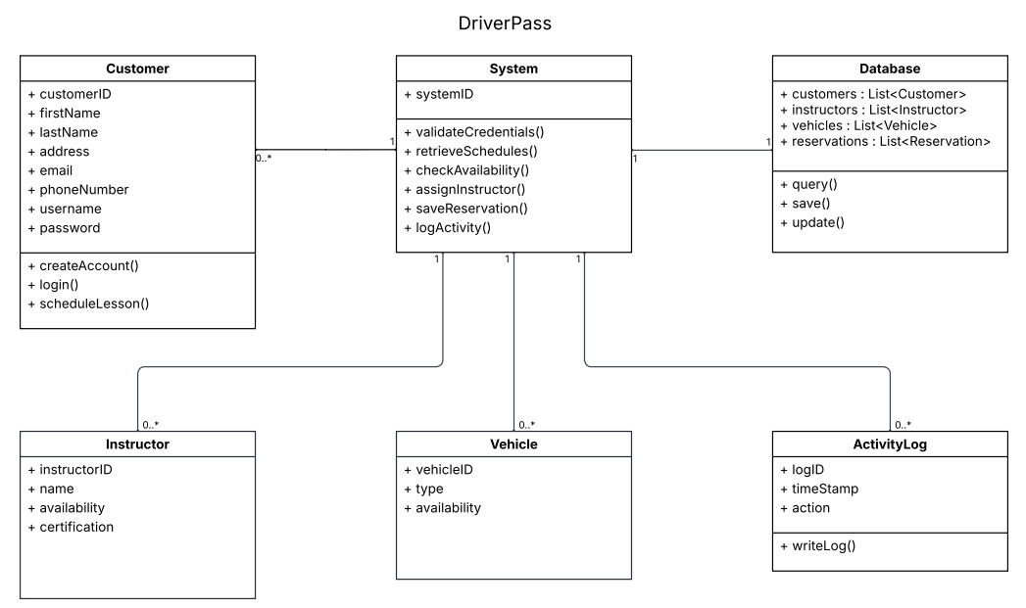

Technical Requirements

The DriverPass system will use a cloud-based infrastructure that allows customers and employees to access the system through a web browser on desktops, laptops, tablets, and mobile devices. DriverPass does not want to manage servers or backups, so everything will be hosted through a cloud service provider. The system will use web servers and a database to store customer accounts, appointments, instructors, vehicles, training packages, lesson notes, test results, and activity logs.

The system will run as a web application that supports account management, scheduling driving lessons, online classes, practice tests, reporting, and tracking activity. It should work on Windows, macOS, Android, and iOS devices without needing any extra software installed. Users will also need reliable internet access and a modern web browser to use the system. Security will include usernames and passwords, different access levels for different users, encrypted data when it is sent between the user and system, secure storage of customer and payment information, password resets, and locking accounts after too many failed login attempts.

The system will also connect with DMV updates so practice tests and study materials stay up to date. Management will be able to download reports for offline use in tools like Excel. The system will be designed and documented using tools like Lucidchart, Word, and PowerPoint, and it needs to run smoothly with quick updates to appointments and records.

